Joel Robitaille

B00200522

April 5, 2017

Assignment #10 – Final Draft

The Effect of Proximity to Universities on Housing Prices in Peninsula Halifax

Prepared for

ECON 4200: Honours Thesis

Abstract

This paper examines the connection between proximity to universities and the value of dwellings in the Halifax peninsula. To assess this relationship data on physical and location characteristics of dwellings in the study area are collected, and a regression of dwelling values against these characteristics is conducted. The study finds that there is a significant and substantial positive relationship between proximity to universities and housing values in the peninsula of Halifax.

Keywords: housing prices, location, university

JEL Numbers: R21, D12

*1. Introduction*

The theory of urban location, which predict higher demand and housing cost with respect to proximity to job centers as consumers attempt to minimize their total location costs is well established by Alonso (1960) and Evans (1973) and it has been studied in a number of settings. In most of these studies the central business district is taken as the job centre of choice. In spite of the fact that universities in many ways function in a similar manner, there is far less consideration given to how they act as economic focal points and their effect on property values of surrounding areas. This paper seeks to answer the question of what is the connection between proximity to universities and the value of dwellings by examining the Halifax peninsula. The results contribute to understanding the distribution of dwelling values in Halifax, and other communities with large universities. The results can also give clues as to how significant the factors that drive the importance of proximity to a university are to the determination of housing values. A large positive relationship between proximity and dwelling values may also be an indication of a supply imbalance in areas surrounding universities.

One approach to assess this relationship is to collect data on the average dwelling values of neighbourhoods for which statistical information is maintained, such as census tracts, and conduct a simple regression of these values against the estimated distances to the nearest university. The drawback of this approach is that it does not allow for control of variations in individual housing characteristics, such as dwelling size. Therefore, this type of analysis is of limited analytical use. To overcome this issue this research collects microdata on the values and characteristics of all individual dwellings in the study area. This research design allows for an examination of the effect of changes in the distance to the nearest university, while controlling for variation in other dwelling characteristics.

This paper will survey the existing literature on location based housing valuation, and describe in detail the conceptual framework of the factors at play in the housing market. The paper will then describe how the relationship between the key variables is observed and the sources of microdata that are used in the hedonic regression, and then present the findings. The conclusion will tie together the outcome of this analysis and present some suggestions for further study.

*2. Background and related literature*

The basic theory of housing valuation as summarized by Glaeser (2007) states that the value of a dwelling like any other product is related to a series of characteristics that determine its desirability to a potential consumer. Since housing is often an investment product, a speculation premium is also added to its price (Sun, Zheng and Wang 2015). Glaeser (2007) elaborates that, all other things being equal, including geographical features and housing size, the primary driver of housing demand is distance to the center of employment as potential residents attempt to minimize their total location costs as is also suggested by Alonso (1960) and Evans (1973).

A complete model of housing prices incorporates a large range of dwelling characteristics, which are split into the physical characteristics, such as, square feet of living space, number of bathrooms and connection to city services; and location based characteristics, such as proximity to parks or elementary schools, and distance to the economic activity center (Do-Yeun 2009).

Do-Yeun (2009) identifies a number of empirical studies that have been completed to assess the impact of proximity to location based amenities, such as elementary schools (Jud 1985) and parks (Weicher 1973) on housing value. In almost all cases, a positive relation between proximity and price is identified which shows that the value that these amenities provide is reflected in prices.

A common approach used to assess the contributions of various characteristics to housing value is the hedonic model, which is described in detail in Rosen (1974). In a hedonic regression one gathers product price information for various versions of a product where the component characteristics differ and then regresses the values against the characteristics to isolate how each characteristic contributes to product value. In this research paper, distance to the nearest university is the product characteristic that is isolated through a hedonic regression.

There have been several studies conducted on the relation of the proximity to the central business district and housing values, some of which used a hedonic model, which are surveyed by Glaeser (2007). The majority of these identified positive relationships between values and proximity, but Glaeser (2007) notes that in some case the relationship was complicated by the existence of other factors determining value, and in some cases the studies were limited by methodological constraints.

To my knowledge, literature regarding the impact of proximity to a university as an economic focal point, is very limited. Do-Yeun (2009), who examines the effects of proximity to Purdue University on apartment rents, is one of the primary authors to have studied this. In the result of his regression analysis he shows a significant and substantial relationship between proximity and apartment rents. This paper differs from Do-Yeun’s study in that I wish to study the effect on housing prices as opposed to rents. In general, I hope to find whether the pattern identified by Do-Yeun repeats itself in housing prices in the neighbourhoods surrounding the universities in peninsula Halifax.

*3. Conceptual framework*

The justification for including proximity to a university as a characteristic that is expected to drive value is based on a model that supposes four things. The first is that housing demand increases as one moves closer to an economic focal point. The second is that due to the finite quantity of land at a given location, increasing per unit costs of construction on a fixed parcel of land (Evans 1973), and planning regulation, the supply of housing in a fixed area is inelastic to price in both the short and long-run. The third is that, in addition to impacting the market directly through higher dwelling prices, higher demand also impacts prices indirectly through higher rents. The fourth is that the universities in Halifax’s south end act as economics focal points, and that the population who attend them generate increased demand for housing at proximity to the universities. The first three suppositions are well supported by established economic theory and evidence. The fourth is a permutation of the economic theory urban location, where the economic focal is a university rather than a central business district.

The first point relates to the theory of urban location, as described by Evans (1977), which states that the determination of a consumer’s location preference is based on minimizing his total location costs. Total location costs consist of two parts: actual housing cost - the rent, or mortgage for a given dwelling - and the travel costs to an individual’s job or daily activity centre. Travel costs are further split into direct travel costs, such as gas and car ownership, and the costs of the amount of time spent commuting. Although a large part of the population being considered the this scenario are students, for students attending school full time and making their own accommodations decisions, proximity to the university campus occupies a similar importance in the cost minimization decision as it does for employed person’s in relation to their place of work. It is a location that the individual must commute to on a daily basis.

In its simplest form the location preference model developed by Alonso (1960) and expanded by Evans (1973) presupposes that all individuals in a city work in one central location and that direct and indirect transportation costs increase as one moves away from this location. While the extreme assumption of a monocentric distribution of employment is not representative of reality, it is a good jumping off point for a model. In the literature Alonso (1960) and later Evans (1973) acknowledge the possibility of multiple centres of employment affecting the distribution of demand, and incorporating these into the model. Universities are not always thought of as economic centres but in terms of their crucial components they function in much the same way in terms of urban location decisions. The universities of the Halifax peninsula certainly meet the primary criteria of a large population that needs to commute to them on daily basis. Based on official number published by the Association of Atlantic Universities there were a combined 23,134 full time students enrolled in 2016-17 at Dalhousie University’s Halifax campuses and Saint Mary’s University. Info from the websites of Dalhousie and Saint Mary’s states that there are also 7,737 current staff members between the two institutions. These student and staff populations represent a substantial concentration of people commuting to these destination in the south end on a daily basis, especially compared to the total population of the peninsula of around 65,000. This population therefore represents a large amount of potential additional demand for areas near universities.



Figure : Full–time student in 2016-17 and staff for Dalhousie University’s Halifax campuses and Saint Mary’s University

The next question is how important is it for university students and staff to live close to campus. There are a number of reasons why the advantages to being close to campus may be greater for students than the advantages for the average person on being close to their place of work. One is that students attending urban universities are generally considered to have lower car ownership rates than the general population, making their commuting more expensive in terms of time. In a 2014 study of ‘Travel Behaviour of Dalhousie Commuters’ the Dalhousie Transportation Collaboratory found that of 709 student respondents only 11.9% drove to school as their primary mode of transportation (Habib 2015). The same study showed that 34% of all respondents and 51.3% of students walked to school as their primary form of transit. This is a commuting pattern that relies much more heavily on short distance transportation methods than the average for metropolitan areas. Proximity may also be of particular value to student because there are social and academic environmental benefits to being on or near to the campus community. A large amounts of student social, extracurricular and after-class studying activities are focused on campus, in a way that a working person’s after work activities are not focused in the areas around their job site. There are increased costs in terms of transportation time or forgoing these activities for students living farther away from campus. Kuh et al (2001) find that students living on or near campus score higher on a host of success indicators including engagement compared to those who commute from long distances. It is my contention that many students realize this and that it is another factor that drives demand for being closer to the university campus.

There are several reason why there would be higher housing demand near universities for Dalhousie and St. Mary’s approximately 30,800 students, staff and faculty. In particular, for students, the concentration of after-school activities on or near campus gives reason to believe that the value of being close to campus is elevated compared a standard commuter wanting to be near their job.

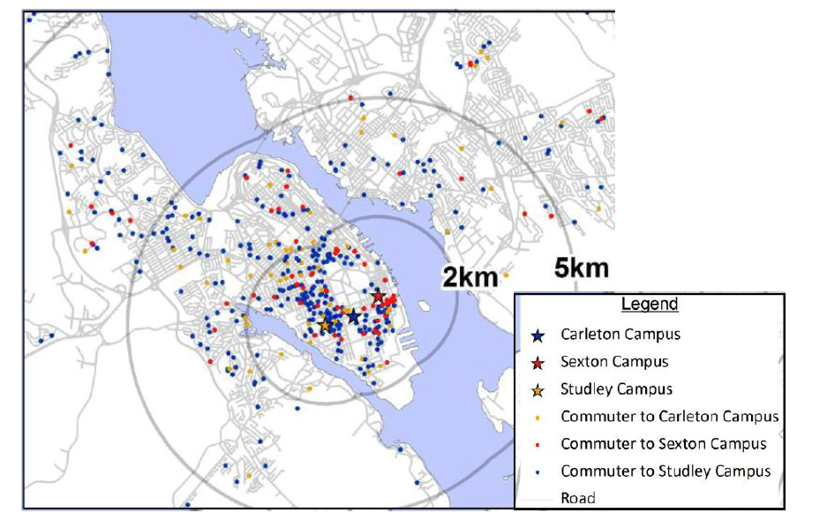There is some concrete evidence that students and staff have a tendency to live closer to campus. In the map in Figure 2, which shows the locations of student and staff respondents to DalTRAC’s 2010 Dalhousie Commuter Survey, you can see a concentration of respondent living in the 2km buffer surrounding the university, with elevated concentration in specific neighbourhoods near the universities (IBI Group 2011). The more current 2014 Dalhousie Commuter Survey (2014) reports that 47.1% of student respondents lived within 2km of their campus. It also reports that 71.5% of students, 46.9% of faculty but only 23.7% of staff lived within 5km of their campus. This shows that both a high proportion of students and faculty choose to live close to campus and highlights the idea that there is an increased propensity to live near campus for students and faculty compared to staff.

Figure . Source: 2012 Dalhousie Transportation Demand Management Plan

One thing that could influence this relationship between proximity to a university and increased demand would be if there were location based factors correlated with proximity to the universities that were also negatively (or positively) correlated with housing desirability. A classic example is a concentration of industrial activity, where its presence makes neighbourhoods less desirable to many potential residents. In the study area there are not many areas for which this would be a factor. One possible exception is the small pocket in the eastern portion of the south end where some vestiges of the port based industrial activity remain.

Another important factor is the consideration of proximity to positive amenities, such as large parks and P-12 schools. Upon reflection I have noticed that there is a concentration of high value dwellings in the areas surrounding Point Pleasant Park on the southern tip of the peninsula. Because this is close enough to some universities, in particular Saint Mary’s, it is possible that for some houses proximity to the park is a factor driving values and that this upwardly biases the estimate of the effect of proximity to a university. Weicher and Zerbst (1973) find evidence that parks do drive housing values, so in further studies it would be beneficial to include a variable for proximity to major parks. Finally, some may suggest that proximity to the waterfront is an important variable to include in a model of housing prices, especially in a study area like the peninsula of Halifax where a large amount of properties are on, or near to, the waterfront. While there is good reason to believe that proximity to the shoreline increases dwelling value, failing to include it in the model should not a critical omission for this study. The reason is that none of the peninsula universities are located on the coast – they are all in-land - and therefor exclusion of proximity to the waterfront should not upwardly bias estimates of the effect of proximity to universities on dwelling values.

There are a number of location based characteristics other than proximity to a university or proximity to the central business district that are expected to influence dwelling value. In some cases inclusion of these variables could improve the model. However, since none of these location features are completely collinear with proximity to universities and the direction of the effects are not all the same it is believed that dis-including them does not substantially affect the general validity of the findings.

A second major assumption of the model relates to the translation of the predicted higher demand to higher housing prices. There are two mechanisms through which higher prices could attain. The first, obvious, method is that in the market for home owners, buyers with a desire to be closer to the university would bid up prices for houses closer to universities. These bidders would most likely take the form of faculty members, and possibly some staff member, who would like to be close to the university as opposed to students. The second, less obvious but probably more important method in which this demand drives prices is through student demand for rental accommodations near universities. Higher demand bids up rent prices near universities, which is exactly what Do-Yeun (2009a) found in his study of rent prices in Layfette with respect to proximity to Purdue University. Then, higher rent prices, in so far as they are an income stream, should increases the assets value of homes that are rented or have been converted into multiple rental units. There has been a broad consensus among those studying the connection between rents and housing prices, including Campbell (2009), Clark (1995) and Meese and Wallace (1994), that in the long run housing prices reconcile to rents based on a dynamic Gordon growth model, which assess housing value as the present value of future rents, including expected rental growth and allowing for changes in the discount rate. There is ample evidence that large amount of the housing stock in the areas surrounding universities has been converted to rental accommodations. A short walk through the Halifax’s south-end will reveal that dwellings that were once private homes and have been converted in income rental apartments are ubiquitous. In addition to higher rents leading to elevated values for income properties they should also have an upward influence on the value of private dwellings. This is because the markets are not separate in that any private dwelling can theoretically be converted into an income property. The asset values of income properties minus conversion costs set a floor for the value of private dwellings in the same area.

A final supposition of the model, and an important one, is that supply is restricted due to a finite amount of land available at any given distance from the universities, increasing per unit development costs on fixed amount of land and in particular restrictions on adding supply in the form of municipal planning regulations, which can prohibit certain scales of development in certain residential neighbourhoods. The result is that increased prices do not get a full scale supply response and that evaluated demand therefor translates through in the form of increased prices.

To summarise the conceptual framework for why proximity to universities is expected to be related to higher dwelling values: in our model university students and employees generate increased demand related to proximity to universities. Coupled with inelastic supply of housing this is expected to leads to elevated housing prices through the owner-occupier market and indirectly though elevated rents in the areas surrounding universities, which is in turn expected to increase the asset value of such dwellings. These elevated asset values are expected to drive both the income and owner-occupier markets.

This process will not be observed directly, but the expected outcome of higher prices can be observed by recovering the implicit price of proximity to a university through conducting a hedonic regression of prices against dwelling characteristics.

*3.1 Empirical Method*

The relationship between the distance a university and dwelling value will be estimated by comparing the prices of like dwellings while varying the distance to the university and holding other characteristics constant. This will be done by conducting a hedonic regression of housing prices on the network distance to the nearest university and other dwelling characteristics. For this to be effective it is important to be able to compare dwelling that are alike in almost all regards except their distance to a university. To allow for this the research design includes variables for number of bedrooms, number of washrooms, square footage of total dwelling / number of bedrooms, which is intended to be a measure of spaciousness, dummy variables for construction quality, the inclusion of a garage and the inclusion of a finished basement, and a second location variable for distance to the city center. The inclusion of these additional regressor is expected to allow this research to isolate the effect of proximity to universities on housing values while controlling for other factors.

The study separates and excludes large apartment buildings. The reason for this is that there cannot be an effective comparison between large apartment buildings owned by real-estate corporation and individual dwellings that can be owned by individuals.

*4. Data Sources*

Microdata on the value of individual dwellings in the study area comes from Property Value Services Corporation (PSVC), the official property assessment organisation for Nova Scotia.[1] The data is for the 2016 assessed value of dwellings, which is meant to be a representation of market value arrived at by taking an average recent sales prices in the neighbouring area and adjusting for dwelling specific characteristics. It is important to distinguish this from the “capped assessment value”, which is what tax bills are based on, and is not necessarily based on market value. To determine the fidelity of the assessed values as a representation of market values, a preliminary assessment of difference between 2016 assessed value and actual sales values, using 2016 sales data from PVSC, found that on average assessments were relatively close to sales values, at approximately $18,000 above. Based on this it is believed that assessed values are a reasonable representation of actual market values.

In addition to assessed values, the PVSC also has data on a number of dwelling characteristics including number of bedrooms, number of bathrooms, square feet of living space, construction quality, and the existence of a garage or a finished basement. These data on physical housing characteristics were retrieved and windowed to the study area. They were then matched to predictor variables that are expected to contribute to the dwelling value.

For the location variables, data for the network distance of each dwelling in the study area to the nearest major university were calculated in ARCGIS using the geographic location of each civic address, a road-network layer and the network analyst tool. This gives the distance in metres to the nearest campus. Distances were calculated to the center point of the campus, while applying a cost layer to the campus border whereby after crossing the campus border distances were added at 10% of the their actual amount. This has the effect of making all dwellings on campus be assessed as close to zero distance from the university. A similar calculation was done for the distance to the central business district, where distance where calculated to city hall with 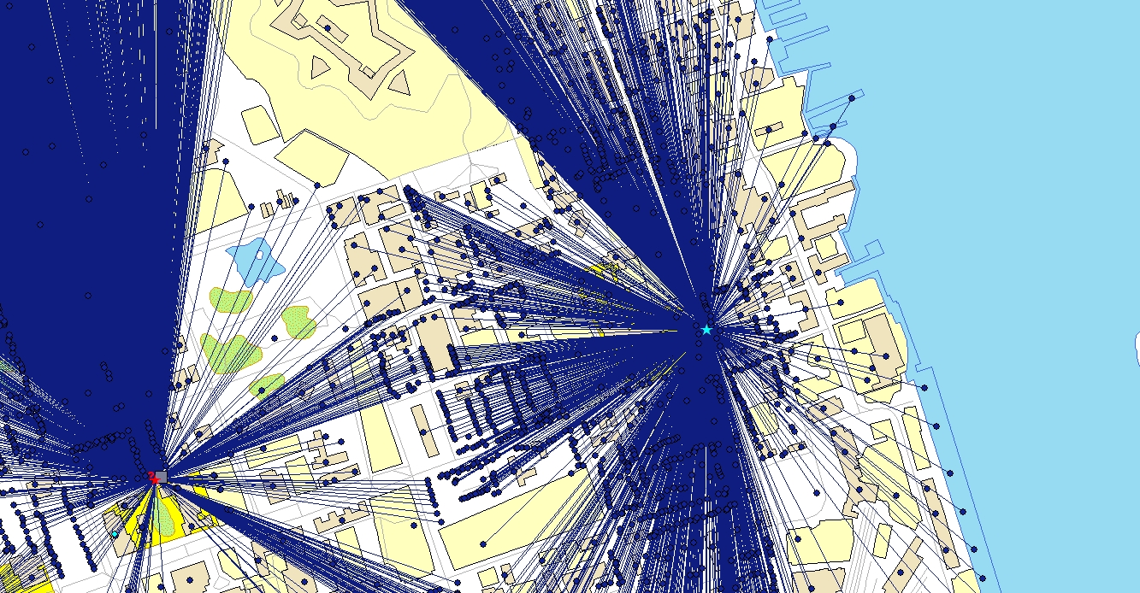a reduced cost layer surrounding the downtown core and 30% cost for distances within the core.

Figure : Representation of the distance calculation from each civic address to the nearest university campus.

Data from the distance calculation files, which included all civic address on the peninsula, and the dwelling characteristic file, which included all residential dwellings for Halifax were merged to create a file of all residential dwellings on the peninsula of Halifax. Outliers in this data set were then identified an examined to determine if they met the criteria of the study population of being residential dwellings and then included or removed as appropriate.

*4.2. Research Design*

To answer the research question of whether there is a statistically significant positive relationship between the proximity of dwellings to a university and their value, this study gathers the above mentioned micro-data for all residential dwellings in the study area of the peninsula of Halifax and maps them to variables that are expected to contribute to a dwelling’s value. The analysis regresses the assessed value of the dwellings against the predictor of interest, the distance to a university, and the other physical and location characteristic of the dwellings.

The full regression model is:

Where, i = 1,…,n and consists of residential properties in the study area.

The physical characteristics used are: number of bedrooms, number of bathrooms, a measure of spaciousness created by dividing square feet of living space by the number of bedrooms, dummy variables for the professional assessment of construction quality, a dummy variable for whether the dwelling includes a garage and a dummy variable for the presence of a finished basement. Location characteristic variables included are: the network distance to the nearest university campus, and the network distance to the central business district in metres. Summary statistics of these variable are presented in Table 1.

At the core this is a hedonic regression, which seeks to isolate the market value of various characteristics of a product – in this case housing - by regressing the price of versions of the product against variation in its characteristics.

*5. Results*

In all iterations of the regression *Distance to Nearest University* is significant at the 99% confidence level and appears to be one of the primary drivers of housing values. In the basic univariate regression, the estimated average change in housing value related to being 1km closer to a university is $76,832. The general relationship can be seen in the plot in Figure 5. It should be noted that the coefficients for *Distance to University* in the regression results in Table 2 are negative, which is the opposite of the way they are being discussed here. The co-efficient regression results table has the literal interpretation of being the decrease in value as one moves away from the nearest university, but for the sake of day-to-day interpretation the results are presented as the increase in value as one moves closer.

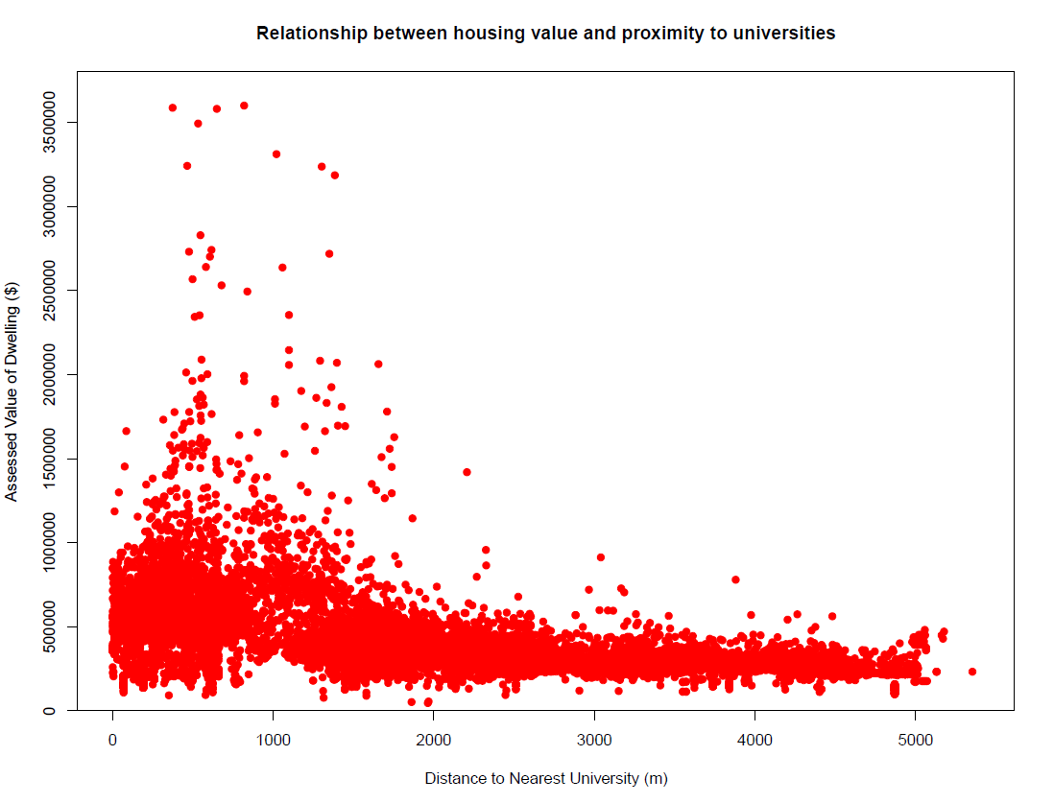

Figure 4: Plot of data points for distance to the nearest university against assessed values

Because proximity to the downtown core is predicted to be positively related to housing values, urban location theory suggests that the first step in adding detail to model should be to add a regressor for the distance to the central business district, especially since in Halifax the distance to the downtown core is fairly collinear with distance to universities. In a surprising result, in the bivariate regression the estimated effect of being closer to downtown core is negative for the Halifax peninsula. Average values decrease by $109,005 for every 1 km one moves closer to the core. Another result of this is the realization that the initial exclusion of the distance to the central business district negatively (rather than positively) biased the estimate for the effect of proximity to universities. In Model 2, while controlling for distance to the city center, the average value of dwellings increases by $142,421 for every 1 km one moves closer to the nearest university.

The negative relationship between price and proximity to the central business district has some valid economic interpretation. For a study area as small as the peninsula of Halifax, which has a maximum distance from the central business district of 5.2km, it could be said that for the purposes commuting to work once a day or going to the downtown core occasionally for amenities, all locations in the peninsula are effectively “close” to the downtown core. It could be the case that while there is a value to being within a certain proximity of the downtown for the average peninsula resident, people also prefer to be in neighbourhoods slightly removed from the business of the downtown core. A previous study of average housing values for census tracts in Halifax Regional Municipality (Robitaille, 2016) finds this to be true. For locations greater than two kilometres from the downtown core the gradient of housing prices increases with proximity, but for locations less than 2 kilometres away the relationship is less clear and essentially reversed.

To further refine the validity of the estimate, data for physical characteristics that are expected to be crucial to determining the value of a dwelling are added to the regression. Model 3 includes variables for number of bedroom, number of bathrooms, spaciousness, and dummy variables for construction quality, and whether the property has a garage or a finished basement. In Model 3 average housing values increase by $94,629 for every 1 km closer to a university. As expected, the estimate of the effect of proximity to universities was slightly lower when controlling for physical characteristics. It was expected to be lower because of the elevated concertation of larger size dwelling in the south end neighbourhoods surrounding universities. What is surprising is that after controlling for this the estimate remains as large as it is in magnitude. This finding is significant at the 99% level, with a standard error of only $1,837 per km.

*Other determinants:*

Many of the other characteristic are also shown to be strong predictors of dwelling values. Increasing the number of bedrooms by one increases average dwelling value by $29,648 (Model 3) or approximately 5.8% (Model 4). Similarly, an increase in the number of bathrooms by one is related to an increase in average values of $37,182 or 6.2%. Compared to the effect of moving 1 km closer to a university these are surprisingly small effects. To add value equivalent to the average increase related to being 1 km closer to a university one would have to add three bedrooms or almost three bathrooms. This shows that, on average, housing consumers on the peninsula value location amenities more than increases number of bedrooms or bathrooms.

The measure of spaciousness, defined as square feet / number of bedrooms is also substantial driver of dwelling values. An increase in spaciousness of 100 square feet / bedroom is related to a $26,632 increase in average dwelling values. This estimate, as well as those for number of bedrooms and number of bathrooms, are all significant at the 99% confidence level. These show that the basic variables relating to housing size play an important role in determining housing value in addition to other factors.

The R squared for the regression in Model 3 is 0.759, which shows the model explains a large amount of the variation in housing values across the peninsula. The magnitude and significance of the estimate for the effect of proximity to the nearest university establishes that this is a significant relationship in the peninsula of Halifax.

Model 4 converts the response variable into the natural logarithm of itself, which is done because this better models the way changes in characteristics relate to housing values. This gives the coefficients the interpretation of being percentage changes in assessed value for unit changes in the characteristic variables. The result in this model is that being 1 km closer to a university has an estimated average effect of a 20% increase in a dwelling’s value. The coefficients for all the predictor variables, with the exception of the presence of a finished basement, are also significant at the 99% level in Model 4. This model achieves a slightly higher fit than Model 3 (R squared of 0.776).

*Sensitivity Analysis*

One argument that could be made against the robustness of the estimates in this study is that there are a large number of high value dwellings in the certain parts of the south end, in particular around Point Pleasant Park and the Northwest Arm, whose premium value is driven by some characteristic other those included in the regression. If that were true the fact that these neighbourhoods are more close than they are far away from the peninsula’s universities would mean that these unobserved drivers are inflating the estimate of proximity to a university. The omitted factor driving value may be proximity to Point Pleasant Park or it may be a neighbourhood characteristic related to being located among other high value dwellings. While it was not possible to include a variable for distance to major parks or find a control for spatial heterogeneity in this study, it is possible to examine what the results of the analysis are if we exclude all dwelling with an assessed value over $1,000,000. Model 5 eliminates the two hundred and eighty-two dwellings with values over $1,000,000 from the original population. Excluding the high value dwellings reduces the estimated effect of proximity to universities by about $13,000 per km. When excluding high value dwellings the average effect of moving 1 km closer to a university is an $81,978 increase in dwelling value. The relationship between proximity to universities and dwelling is strong even when omitting the highest value dwellings.

*6. Conclusion*

This research paper aimed to find the connection between proximity to universities and housing values. To find this, micro data on the assessed values and associated physical and location characteristics of houses on the peninsula of Halifax were collected. These were used to conduct a regression of values on the characteristics. The resulting co-efficients give us estimates for the average contribution of a unit change in each characteristic to dwelling value. Controlling for most physical characteristics and the network distance to the downtown the average effect of being 1 km closer to a university is a $81,978 or 20% increase in dwelling value. This show there is a strong relationship between proximity to universities.

This finding is important for agencies trying to understand and assess dwelling values in markets with a large university. The strength of the relationship, when compared to physical characteristic predictors, suggest that it may be valuable to include distance to a university as variable in determining property value assessments. The findings of this study are also important in terms of understanding the distribution of dwelling values in Halifax, how it came about and what factors affect it. Finally, the strength of the relationship gives some information about how factors that influence university based housing demand, such as potential increases to the size of the student and staff populations, may affect the housing market in the areas near universities.

*Appendix*

|  |  |  |  |  |  |
| --- | --- | --- | --- | --- | --- |
| Table 1: Descriptive statistics of regression variables | | | | | |
|  | | | | | |
| Variable | N | Mean | St. Dev. | Min | Max |
|  | | | | | |
| Assessed Value (2016) | 13,282 | $414,755 | $237,088 | $46,600 | $3,599,900 |
| Number of Living Units | 13,282 | 1.3 | 0.7 | 1 | 15 |
| Age | 10,461 | 64.1 | 32.3 | 1 | 201 |
| Square Feet of Living Area | 10,223 | 1,937.9 | 904.6 | 399 | 11,467 |
| Sq. ft. / # Bedrooms | 9,630 | 549.9 | 237.2 | 123.8 | 5,760.0 |
| Bedrooms | 12,450 | 3.2 | 1.5 | 1 | 24 |
| Bathrooms | 13,097 | 2.0 | 1.0 | 1 | 17 |
| Average Quality Dummy | 10,224 | 0.5 | 0.5 | 0 | 1 |
| Good Quality Dummy | 10,224 | 0.4 | 0.5 | 0 | 1 |
| Very Good to Excellent Quality Dummy | 10,224 | 0.0 | 0.1 | 0 | 1 |
| Finished Basement Dummy | 13,282 | 0.3 | 0.5 | 0 | 1 |
| Garage Dummy | 13,282 | 0.2 | 0.4 | 0 | 1 |
| Distance to Nearest University (m) | 13,282 | 1,828 | 1,362 | 2 | 5,353 |
| Distance to Central Business District (m) | 13,282 | 2,366 | 1,053 | 316 | 5,189 |
|  |  |  |  |  |  |
| Total number of observations | 13,282 |  |  |  |  |

|  |  |  |  |  |  |
| --- | --- | --- | --- | --- | --- |
| *Table 2: Regression Results* | | | | | |
|  | *Dependent variable:* | | | | |
|  |  | | | | |
|  | Assessed Value | | | ln(Assessed Value) | Assessed Value |
|  | Model 1 | Model 2 | Model 3 | Model 4 | Model 5 |
|  | | | | | |
| Distance to University (m) | -76.832*** | -142.421*** | -94.629*** | -0.0002*** | -84.757*** |
|  | -1.355 | -2.03 | -1.837 | 0 | -1.08 |
|  |  |  |  |  |  |
| Distance to Central Business District (m) |  | 109.005*** | 78.161*** | 0.0001*** | 56.124*** |
|  |  | -2.626 | -2.515 | 0 | -1.483 |
|  |  |  |  |  |  |
| Number of Bedrooms |  |  | 29,648.100*** | 0.058*** | 25,528.190*** |
|  |  |  | -1,370.19 | -0.002 | -823.792 |
|  |  |  |  |  |  |
| Number of Bathrooms |  |  | 37,182.990*** | 0.062*** | 28,051.250*** |
|  |  |  | -1,941.74 | -0.003 | -1,189.02 |
|  |  |  |  |  |  |
| Sqft Living Area / Bedrooms |  |  | 263.632*** | 0.0004*** | 184.507*** |
|  |  |  | -7.933 | -0.00001 | -4.908 |
|  |  |  |  |  |  |
| Average Quality Dummy |  |  | 66,701.210*** | 0.206*** | 64,437.570*** |
|  |  |  | -6,385.08 | -0.009 | -3,721.35 |
|  |  |  |  |  |  |
| Good Quality Dummy |  |  | 138,795.700*** | 0.358*** | 133,235.600*** |
|  |  |  | -6,769.79 | -0.009 | -3,950.29 |
|  |  |  |  |  |  |
| Very Good to Excellent Quality Dummy |  |  | 592,682.900*** | 0.693*** | 245,115.400*** |
|  |  |  | -12,544.20 | -0.017 | -10,123.79 |
|  |  |  |  |  |  |
| Garage Dummy |  |  | 39,896.950*** | 0.081*** | 34,706.680*** |
|  |  |  | -3,112.35 | -0.004 | -1,839.01 |
|  |  |  |  |  |  |
| Finished Basement Dummy |  |  | -14,094.670*** | -0.005 | -715.473 |
|  |  |  | -3,182.51 | -0.004 | -1,890.14 |
|  |  |  |  |  |  |
| Constant | 555,190.600*** | 417,185.400*** | -9,237.50 | 12.112*** | 95,608.760*** |
|  | -3,089.28 | -4,415.91 | -10,401.46 | -0.014 | -6,229.20 |
|  |  |  |  |  |  |
|  | | | | | |
| Observations | 13,282 | 13,282 | 9,630 | 9,630 | 9,379 |
| R2 | 0.195 | 0.287 | 0.684 | 0.799 | 0.767 |
| Adjusted R2 | 0.195 | 0.287 | 0.684 | 0.799 | 0.767 |
| Residual Std. Error | 212,745.300 (df = 13280) | 200,161.800 (df = 13279) | 136,461.100 (df = 9619) | 0.185 (df = 9619) | 79,390.370 (df = 9368) |
| F Statistic | 3,214.200*** (df = 1; 13280) | 2,677.128*** (df = 2; 13279) | 2,086.825*** (df = 10; 9619) | 3,817.678*** (df = 10; 9619) | 3,083.296*** (df = 10; 9368) |
|  | | | | | |
| *Note:* | *p<0.1; **p<0.05; ***p<0.01 | | | | |

# Bibliography

Alonso, William. 1960. *Location and Land Use: Towards a General Theory of Land Rent.* Cambridge, Mass: Harvard University Press.

Campbell, Sean D., Morris A. Davis, Joshua Gallin, and Robert F. Martin. 2009. "What Moves Housing Markets: A Variance Decomposition of the Rent-Price Ratio." *Journal Of Urban Economics* 66 (2): 90-102.

Clark, Todd E. 1995. "Rents and Prices of Housing across Areas of the United States: A Cross-Section Examination of the Present Value Model." *Regional Science And Urban Economics* 25 (2): 237-247.

Do-Yeun, Park. 2009a. "Determinants of Market Rents in a Local Rental Housing Market." *Doctoral Dissertation, Purdue University* 1-20.

Do-Yeun, Park. 2009b. "Neighbourhood Effects of Rental Properties on Owner Occupied Housing." *Doctoral Dissertation, Purdue University* 45-69*.*

Evans, Alan W. 1973. *The Economics of Residential Location.* London: The MacMillan Press.

Glaeser, Edward L. 2007. "The Economic Approach to Cities." *The National Bureau of Economic Research.* doi:10.3386/w13696.

Habib, M.A. and M.H. Hafezi. 2015. *Travel Behaviour of Dalhousie University Commuters: An Analysis of Dalhousie Sustainability Survey 2014*. Halifax, NS: Dalhousie Transportation Collaboratory.

IBI Group. 2011. *Transportation Demand Management Plan for Dalhousie Unviersity.*

Jud, G. D. 1985. "A Further Note on Schools and Housing Value." *AREUEA Journal* 13: 452-562.

Meese, Richard, and Nancy E. Wallace. 1994. "Testing the Present Value Relation for Housing Prices: Should I Leave My House in San Francisco?." *Journal Of Urban Economics* 35 (3): 245-266. *EconLit*, EBSCO*host* (accessed November 16, 2016).

Robitaille, Joel. 2016. "Examining the effects of distance from the city centre on housing values: an analysis of housing prices in the Halifax Census Agglomeration." Term paper for Econometrics 3338. Dalhousie University.

Rosen, Sherwin. 1974. "Hedonic Prices and Implicit Markets: Product Differentiation in Pure Competition." *The Journal of Political Economy* 82 (1): 34-55.

Sun, Weizeng, Siqi Zheng, and Rui Wang. 2015. "The Capitalization of Subway Access in Home Value: A Repeat-Rentals Model with Supply Constraints in Beijing." *Transportation Research: Part A: Policy and Practice* 80: 104-115.

Weicher, J. and Zerbst, R. 1973. "The Externalities of Neighbourhood Parks: An empirical Investigation." *Land Economics* 99-105.

1. PVSC recently released the records for all residential dwellings in Nova Scotia to the public as part of an open data initiative. The data can be accessed at www.datazone.ca.